Lab 08

- )

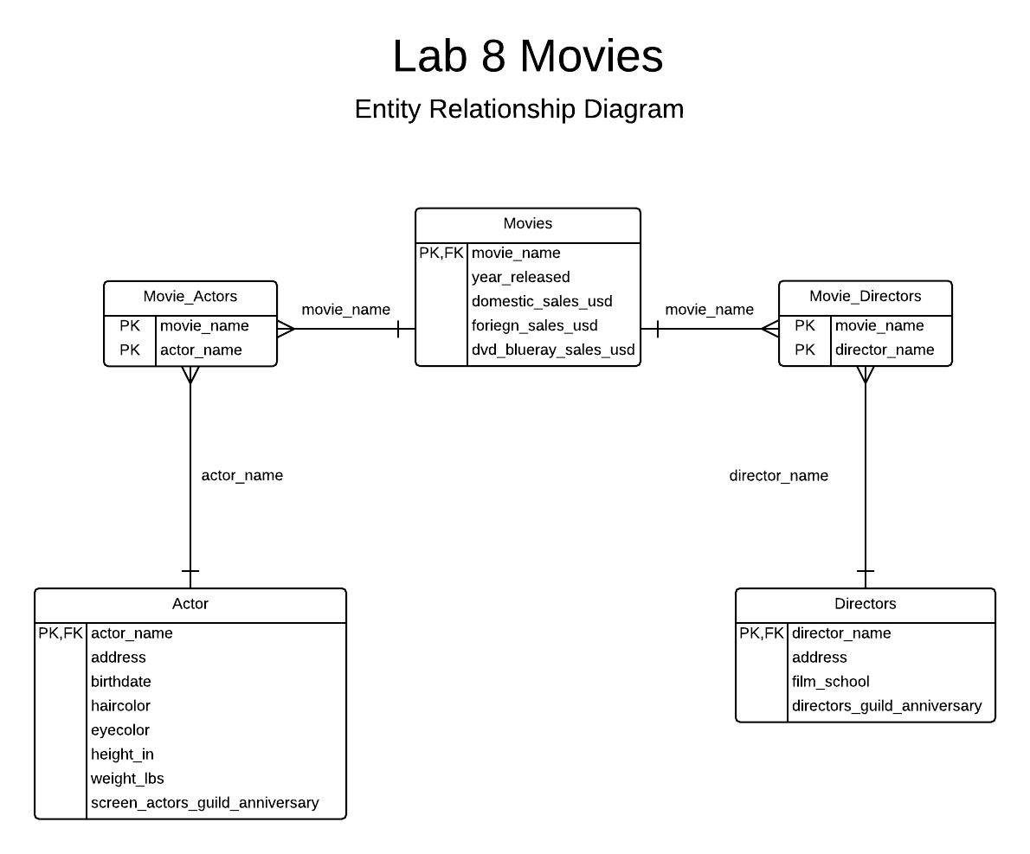
- )

CREATE TABLE Movies (
movie_name text not null,
year_released smallint CHECK(year_released > 1800),,
domestic_sales_usd numeric(12,2),
foriegn_sales_usd numeric(12,2),
dvd_blueray_sales_usd numeric(12,2),
PRIMARY KEY(movie_name)
);

CREATE TABLE Actors (
actor_name text not null,
address text,
birthdate date,
eyecolor char(15),
haircolor char(15),
height_in smallint CHECK(height_in > 0),
weight_lbs smallint CHECK(weight_lbs > 0),
screen_actors_guild_anniversary date,
PRIMARY KEY(actor_name)
);

CREATE TABLE Directors(
director_name text not null,
address text,
film_school text,
directors_guild_anniversary date,
PRIMARY KEY(director_name)
);

CREATE TABLE Movie_Actors(
movie_name text not null REFERENCES Movies(movie_name),
actor_name text not null REFERENCES Actors(actor_name),
PRIMARY KEY(movie_name,actor_name)
);

CREATE TABLE Movie_Directors(
movie_name text not null REFERENCES Movies(movie_name),
director_name text not null REFERENCES Directors(director_name),
PRIMARY KEY(movie_name,director_name)
);

- )

INSERT INTO Movies(movie_name,year_released,domestic_sales_usd,foriegn_sales_usd,dvd_blueray_sales_usd)
VALUES('Entrapment',1999,87704396.00,124700000.00, 1500000.00),
('Finding Forrester',2000, 51768623.00 , 28245000.00,1245555.00 ),
('The League of Extraordinary Gentlemen',2003, 66465204.00, 112800000.00, 36400000.00 ),
('GoldenEye',1995,106429941.00,245764093.00,22389000.00);

INSERT INTO Actors(actor_name,address,birthdate,haircolor,eyecolor,height_in,weight_lbs,screen_actors_guild_anniversary)
VALUES('Sean Connery', 'Fake Addres 3033, Podunk, NW 32113', '08-25-1930','brown' ,'brown', 56, 216,'06-18-1954' );
INSERT INTO Actors(actor_name)
VALUES('Catherine Zeta-Jones'),
('Rob Brown'),
('Stuart Townsend'),
('Pierce Brosnan');

INSERT INTO Directors(director_name,address,film_school,directors_guild_anniversary)
VALUES('Jon Amiel','Some Address 3933, NoWhere, NW 32033','University of Cambridge','03-24-1982');
INSERT INTO Directors(director_name)
VALUES('Gus Van Sant'),
('Stephen Norrington' ),
('Martin Campbell');

INSERT INTO Movie_Actors(movie_name,actor_name)
VALUES('Entrapment','Sean Connery'),
('Entrapment','Catherine Zeta-Jones'),
('Finding Forrester','Sean Connery'),
('Finding Forrester','Rob Brown'),
('The League of Extraordinary Gentlemen','Sean Connery'),
('The League of Extraordinary Gentlemen','Stuart Townsend'),
('GoldenEye','Pierce Brosnan');

INSERT INTO Movie_Directors(movie_name,director_name)
VALUES('Entrapment','Jon Amiel'),
('Finding Forrester','Gus Van Sant'),
('The League of Extraordinary Gentlemen','Stephen Norrington'),
('GoldenEye','Martin Campbell');

- ) Movies
movie_name -> the set and all subsets of {year_released,domestic_sales_usd,foriegn_sales_usd,dvd_blueray_sales_dvd}

Actors
actor_name -> the set and all subsets of {address,birthdate,haircolor,eyecolor,height_in,weight_lbs,screen_actors_guild_ anniversary}

Directors
director_name -> the set and all subsets of {address,film_school,directors_guild_anniversary}

Movie Actors
movie_name,actor_name -> * None *

Movie Directors
movie_name,director_name -> * None *

- )
select distinct movie_directors.director_name from movies
inner join movie_actors on movies.movie_name = movie_actors.movie_name
inner join movie_directors on movies.movie_name = movie_directors.movie_name
where movie_actors.actor_name = 'Sean Connery'
order by movie_directors.director_name ASC;

